How could a national organisation provide their state and national awardees with a report card on their leadership to advance the 17 UN SDGs?

**Main Goal Focus**: 1, 2, 4, 6, 7, 12 and 16

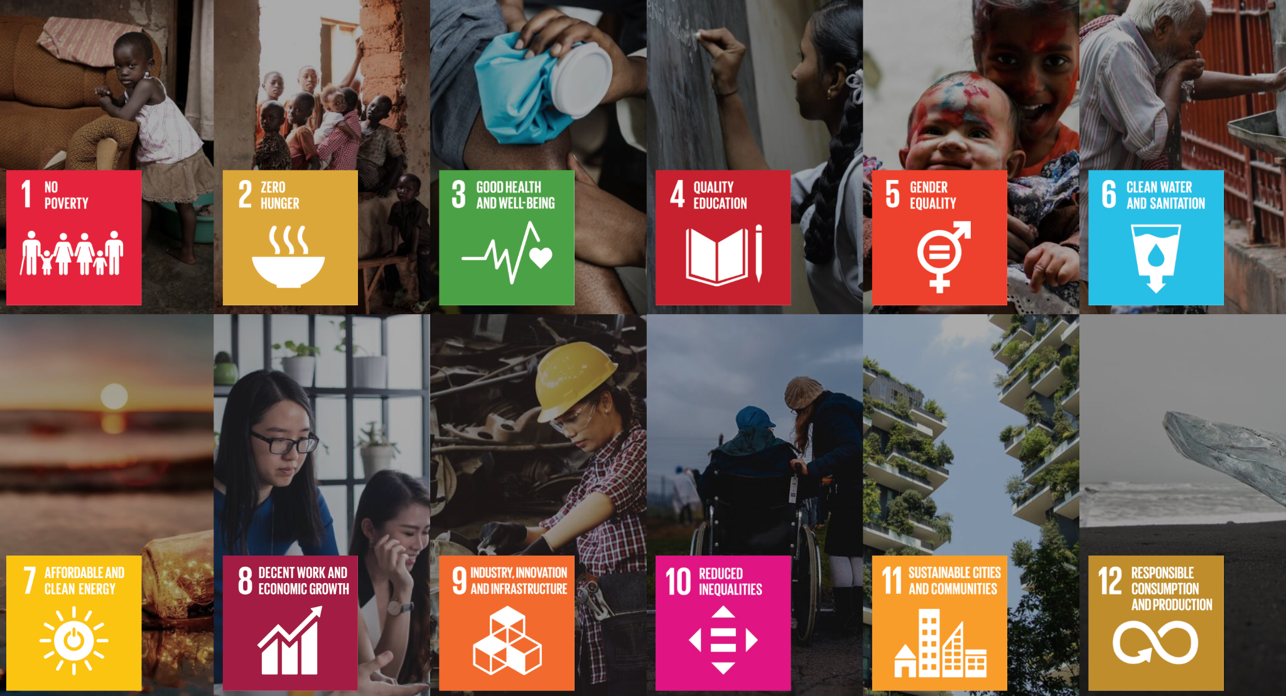

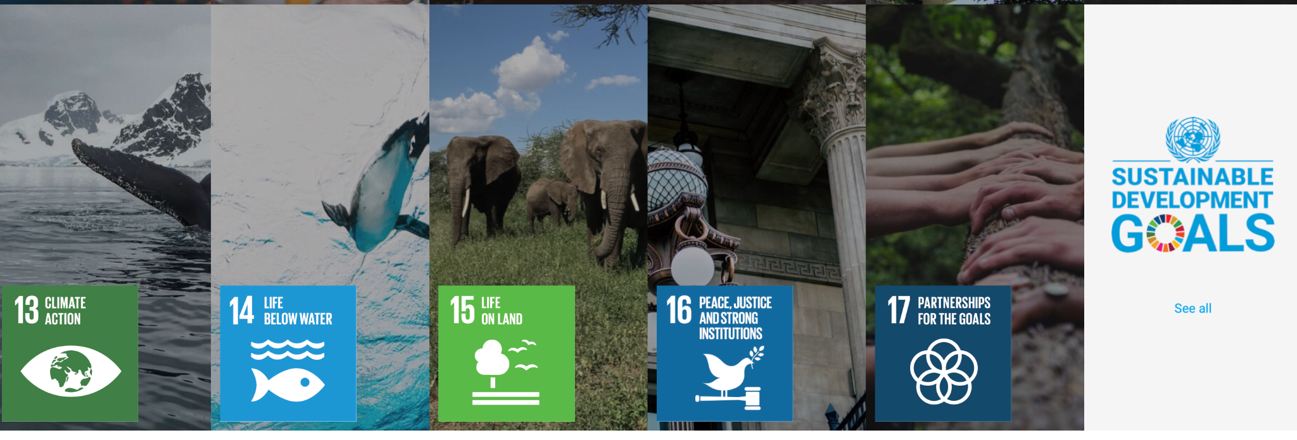

**2022 Winners**

# *Biodiversity award*

### (Winner) Sydney Institute of Marine Science: Living Seawalls

### SDGs: 11 (Sustainable Cities and Communities), 14 (Life Below Water)

Concrete/Stone shoreline protection devices are used to protect shores for human use. These structures destroy and replace natural habitats and can modify the surrounding sea-floor, often negatively impacting biodiversity and ecosystem services, including clean water maintenance and fisheries production, on which humans rely.

By fitting panels that mimic the habitat features of natural shorelines, sea walls can be colonised by seaweeds, shellfish and other marine life. These devices can be used on new structures or be retrofitted to existing ones.

Since 2018, the team has partnered with Volvo Cars Australia and 5 local governments to install LS panels on 10 seawalls in Sydney, as well as a collaboration with Lendlease to create an underwater garden at Barangaroo. LS also installed in 3 other major Australian cities as well as in Singapore, Gibraltar and Wales.

LS has been scientifically demonstrated to enhance seaweeds, fish and invertebrates such as crabs and shellfish after as little as one year. The benefits can extend to enhanced water filtration to fish communities and minimises the establishment of pest species.

Team has developed frameworks for ecologically enhancing marine infrastructure that are being implemented by Lendlease and used by NSW Gov to plan major urban renewal projects like Sydney Fish Markets.

LS has been featured in gov guidance documents like Fish Friendly Infrastructure and breakwater upgrades. LS has been the focus of over 20 local and national print, TV and radio news stories since first installation in 2018. The project generated local, national and international awareness of eco-friendly construction through public seminars and outreach events, stakeholder workshops and through social media.

LS has been featured in LAndscape Architecture Australia (2020), Sustainability Mag Luxembourg (2020) and in 7 national and international exhibitions, including at leading design museums of Europe and America. Finalist for the 2021 Earthshot Prize

### Eastern Barred Bandicoot Recovery Team

### SDG: 15 (Life on Land)

Eastern Barred Bandicoot saved the EBB from near extinction, resulting in reclassification by Vic Gov from ‘extinct in the wild’ to ‘endangered’.

Crucial work in 2019-2021 including the largest ever reintroductions, new habitat and forward-thinking trials, the EBB has been set up for a future safe in the wild. With strong partnerships, a long-term strategic focus and meaningful funding, species can be saved from extinction.

EBBs suffered a catastrophic decline due to rapid settlement and land clearing in the 19th century, and the introduction of the red fox.

The EBB Recovery Team was formed in 1988 and all animals that could be trapped were moved to a captive breeding program as the last wild population became extinct. Breeding was quickly established in captivity, providing insurance against extinction and producing bandicoots for translocation to new sites. In the 1990s all but one of the reintroduction attempts failed due to foxes.

In 2004 a new fence design proved successful in excluding foxes altogether and is now used across all fenced reserves. In addition to the almost 2000ha of fox-free reserves within the original range, the EBBRT decided to introduce bandicoots to large fox-free islands outside their historic range.

EEBs are now establishing across Churchill, Phillip and French Islands, which together provide around 20,000ha of suitable habitat.

As of 2021, populations are secure across 4 fox-free fenced reserves and 3 fox-free islands. The total population size is conservatively estimated to be at 1,500 and growing.

Demonstrated successes gave government and non-government organisations confidence to invest in

this program, and island communities fell in love with EBBs permitting the introductions to islands to occur.

### Wildlife Drones

### SDG: 14 (Life Below Water), 15 (Life on Land), 17 (Partnerships for the Goals)

WD using drone technology to pioneer autonomous environmental monitoring.

Over the last 3 years, developed a cutting edge drone-based radio tracking system, VHawk, that enables researchers, conservationists and land managers to rapidly locate and track multiple animals in real time.

Their system is the first in the world to enable real time data collection and analysis, without the need for internet connection, which ensures users have the insights they need where it matters most—in the field.

Their radio-tracking technology has been used to monitor over 40 individual species—including

some of the world’s most threatened animals like pangolins, kakapo and swift parrots—across a wide variety of ecosystems.

They have partnered with clients across five countries to contribute to global efforts to protect, promote and restore terrestrial ecosystems and halt biodiversity loss—key aims of Sustainable Development Goals 14, 15 & 17.

Working closely with their clients has given them a valuable insight into the ways in which our technology enhances biodiversity conservation programs, by enabling better targeted and more responsive interventions, whether that be for invasive species control, or threatened species protection.

Their path to developing VHawk hasn’t been straightforward, and they have had to overcome numerous challenges, to bring their idea to market. These include learning to navigate the start-up world, finding the right team, technical hurdles and overcoming barriers to adoption as we broke new ground. These challenges have reinforced the importance of passion, determination and collaboration, which is at the heart of their development philosophy.

Over the next three years they will build on their core technology, to develop and deploy autonomous monitoring pods across terrestrial ecosystems globally. Their automated drone pods will automatically gather data from a broader range of sensors (including camera traps as well as acoustic and other environmental monitoring sensors) to quantify and monitor the world’s diverse natural capital, and sync this information to the cloud for detailed, real-time analysis and actionable insights.

They are excited by the potential of Wildlife Drones to revolutionise wildlife monitoring, as they transition into this next phase of their journey, and are currently seeking investment to progress their technology.

#### Differences between winner and nominees:

* More widely applicable, able to cause greater impact or impact a wider variety of animals
  + EBBRT focuses only on EBB
  + Drones can track up to 40 species at once
  + LS can impact entire ecosystems and areas simultaneously
* Proven technology backed by research findings
  + EBBRT is very focused, little indication the same strategy is guaranteed to work for fother similarly critically endangered species
  + Drones are still a new technology, has potential but not proven tech
* International recognition as a result of outreach programs, media stories, etc. etc. (is widely known)
  + LS has international recognition, a large number of awards and accolades, and actively pursues to let themselves be known
  + Relatively little indication of EBBRT and drones having the same degree of outreach

# *Agriculture and Regional Development Award*

### (Winner) Planet Protector Packaging

### SDG: 6, 12

Packaging for the Planet is a company that is dedicated to providing sustainable packaging solutions. The company help reduce the environmental impact of packaging by providing alternatives to traditional packaging products that are harmful to the planet.

The company is by providing packaging products made from biodegradable materials or compostable materials. These materials break down in the environment, reducing the amount of waste that ends up in landfills which helps to conserve natural resources and reduce pollution.

Another way is that Packaging for the Planet offering eco-friendly packaging options. These may include packages that are designed to be reusable, or products that are packaged in smaller amounts to reduce waste. The company also help businesses and individuals transition to sustainable packaging by providing consultation and guidance.

The company's services may also include recycling programs and education. They may work with local communities and organizations to promote recycling and composting, as well as to educate the public on the importance of reducing packaging waste. They may also run or support campaigns that encourage individuals and businesses to reduce their packaging waste.

### Terrain NRM, QLD

### SDG: 15 (Life on Land)

Terrain NRM is a company that specializes in providing sustainable solutions for the management and conservation of natural resources. They offer a wide range of services that aim to protect, conserve and restore natural resources such as land, water, biodiversity and forest.

The company may target different industries such as agriculture, mining, urban development and non-profit organizations to provide sustainable solutions that benefit both the environment and the economy.

One of the key services that Terrain NRM offers is land and biodiversity management. Include services such as conservation and restoration of natural habitats, reforestation, and the management of protected areas.

The company also work to prevent soil erosion and to rehabilitate degraded land. They may work with farmers, ranchers and other land managers to help them implement sustainable land use practices that conserve natural resources while still allowing for economic development.

Another service offered by Terrain NRM is water management. They provide services such as river restoration, water catchment management and the construction of wetlands and other water retention systems. They may also work to protect water quality by controlling sedimentation and erosion, and by reducing the amount of pollutants that enter water bodies. Additionally, they may help communities and businesses to implement water conservation practices and use water more efficiently.

Terrain NRM may also offer consulting and training services for organizations and government bodies on sustainable resource management practices. They may provide guidance on how to implement sustainable practices that conserve natural resources, and may help businesses and organizations to create sustainable resource management plans.

Furthermore, the company may conduct research to understand the effects of different activities on the environment, and to develop strategies to protect natural resources. This can include monitoring and assessment of natural resource condition, or research on the best ways to restore or manage specific habitats or ecosystem.

# *Circular Transition Award*

## (Winner) Ecologiq

### SDG: 4, 6, 7, 8, 9, 10, 11, 12, 13, 17

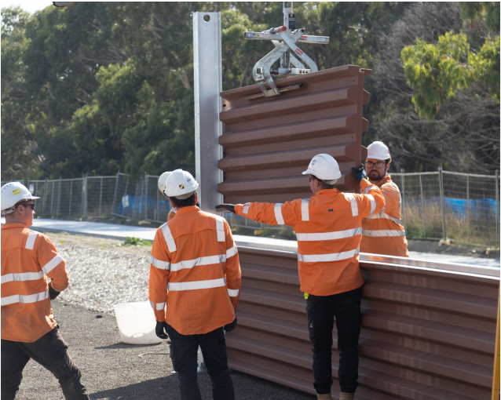

Ecologiq is a Victorian Government initiative that integrates recycled content across Victoria’s transport infrastructure projects and makes using green materials business-as-usual.

A key driver to this policy is the Council of Australian Government’s move to ban the export of waste, plastic, paper, tyres and glass in 2020, which includes the requirement of transport infrastructure contractors to optimise their use of recycled and reused materials.

One key example that embodies this policy is the succesful installation of the world’s first 75 per cent recycled plastic noise panels on the Mordiallic Freeway. The project used around 800,000 tonnes of recycled and reused materials which boasts the project’s reputation as Australia’s greenest freeway.

Other recycled content used includes:

* 46,000 tonnes of recycled asphalt pavement
* 100,000+ cubic metres of crushed concrete
* 340,000+ cubic metres of recycled fill
* 14,000+ tonnes of recycled glass
* 25,000+ tonnes of supplementary cementitious materials (made from industry by-products)
* 3,500 tonnes of recycled steel
* 700+ tonnes of recycled plastic.

This project has paved the way for the new specification, utilising recycled plastic, which will guide future Victorian Big Build projects as well as Department of Transport’s projects going into 2023.

More than 10 Victorian suppliers of recycled and reused products were used to deliver the new freeway, generating economic benefits and job security.

## Planet Protector Packaging (PPP)

### SDG: 5, 8, 9, 11, 12, 13, 14, 17

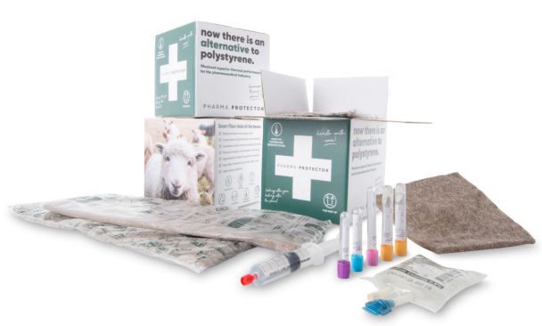

PPP is on a mission to eliminate polystyrene and is in the race to become the market leader in sustainabl thermal packaging that doesn’t harm the planet.

The biggest problem in this industry is the fact that each year 8 million tonnes of plastic enter the ocean with 42% coming from the packaging industry. Expanded polystyrene (EPS) is amongst the worst plastic impacting our waterways and oceans.

Their innovative WOOLPACK packaging solutions are reusable, compostable, thermally stables, and unique in the packaging sector. WOOLPACK is made from 100% biodegradable and compostable felted sheep’s wool, sealed within a recyclable food grade polyethylene liner. This wool is actually “waste wool” from the wool mills so it has the added benefit of helping to reduce landfill.

Some of their unique solutions include Vaccine Protector, now approved by Medsafe (NZ Health Ministry), an dbeing used to rollout Pfizer vaccine in NZ, and Lobster Protector, 2020 Gold Winner in the Australasian Packaging Innovation and Design Awards (PIDA) category and winner in 3 categories in 2021 World Star Packaging Awards.

As of FYI2021, PPP positive impacts are:

* The elimination of **7.5 million** polystyrene boxes
* Diversion of **3500 tonnes** of waste wool from landfill
* Generation of **$7 million** new income for farmers

PPP are proudly disrupting their way through the conventional packagin industry and promoting circular economy, as there is no planet B!

#### Differences between winner and nominees:

* Ecologiq has a greater impact on the daily lives of everyone as it is the redesign of an entire freeway. Based on facts alone, they have a greater impact on more areas of the environment. Also specifically to this award, Ecologiq achieves a more circular lifecycle of materials compared to PPP.
* PPP has a winning product, as we can see they won the Agriculture and Regional Development Award.
* We have to look at awards themselves, within a specific industry so we can easily compare companies

# *Clean Technology Award*

## (Winner) Degnan Constructions

### SDG: 7, 9, 11, 13, 17

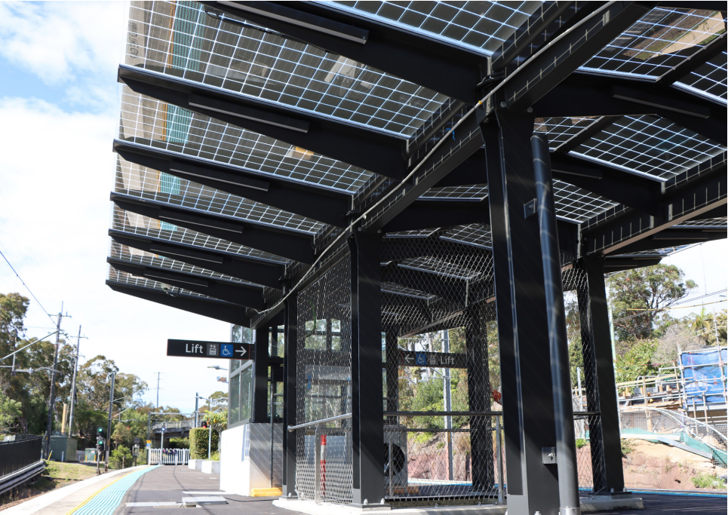

Degnan Constructions understand the client’s (NSW Transport) commitment to deliver sustainable transport infrastructure projects across the network, so the yknew develop a concept that was scalable and transferable was the key to success.

This resulted in the development of a Photovoltaic Glass Canopy which provides shade and shelter while being able to generate enough solar power to run the entire station’s lighting, communications, and general power requirements.

Degnan demonstrated a clear and direct alignment with several SDGs, in particular sustainable cities, industry innovation, clean energy and partnering for success.

### 

### ACT GOVERNMENT

### SDGs: 7,9,11,13

ACT Government has committed to plan an action to ensure at least 50% of the newly leased ACT government vehicles will be zero emission. This has the purpose to reduce emission from the ACT government fleet.

The government ACT planned and made a commitment to other initiatives to support the action from the government ACT including the adoption of 20 hydrogen vehicles and public hydrogen refuelling stations in Australia. The parliamentary and governing agreement was to implement a pathway for the ACT to use only zero emissions public transport, taxi with no further purchase of non-zero emission vehicles and the distribution of deployment public charging infrastructure. The fleet implementation of the installation of charging infrastructure across the ACT government has been achieved to support the transition.

ACT Government has clearly had the purpose to sustain the cities and communities with clean energy and to innovate within the industry and infrastructure.

# *Net Zero Award*

## (Winner) Hesperia

### SDGs: 13, 17

Hesperia is a western Australia’s leading property developer that has the primary action to address climate change to reduce and offset emission. Hesperia has launched their sustainability strategy to improve and influence better environmental, social and economic outcomes in the operations itself.

The purpose of the strategy implemented by Hesperia is to deliver better projects through partnership and innovation with a net zero approach on all projects and carbon neutral operations. Hesperia aims to reduce environmental impacts to zero at every stage.

Hesperia’s primary project pledging to reduce all operation emission of assets, achieve maximum reductions in embodied carbon for new developments, and compensate any residual operational

This property developer is committed to demonstrate leadership for the industry, ensuring ambitions and lessons learned are communicated transparently. Implementing the sustainability strategy was able to turn these into new business opportunities with the primary action on addressing climate change to reduce while many sustainability businesses expected to create large revenue returns.

## Telstra

### SDGs: 7,8,10,12,13,17

Telstra’s environment strategy is delivering on their communication to achieve net zero emission by 2050. Telstra goals towards their action on the leading climate action and delivering results on their journey to net zero emissions including keeping on track to achieve their target for 2030 emission reduction targets by reducing their 1 and 2 scopes emission by 11% from 2019, becomes a carbon neutral organisation through the biggest and most comprehensive voluntary carbon offset program in corporate Australia's history and to achieve the 100% renewable energy by 2025 as 34% has been achieved of the way.

Telstra has also announced the launch of the telstra energy, the renewable energy projects that will be offered and revolutionise to all the household and businesses carbon neutral energy in Australia.

The renewable energy project from telstra has not only impacted the environment but also helped Australia and the Australian to reduce the emission and decarbonise, and it has also contributed to a range of SDGs 7,8,10,12,13,17.

#### Differences between winner and nominees:

-Hesperia aims to offset emission to zero at every stage. The strategy’s purpose to deliver better projects through partnership and innovation with a net zero approach on all projects

-Telstra project is to launch renewable energy that will be offered and revolutionised to all the household and businesses carbon neutral energy in Australia and targeted to have 100% renewable energy by 2025.

Banksia Foundation Sponsors

## 1. EY

The EY serves as a global leader in tax, transaction, assurance and advisory services. They have a team that comes from different backgrounds, which helps the businesses to move on with their sustainability plan to the next level. The reason for EY to become sponsors for Banksia Awards is because it allows EY to bring the sustainability goals forward in the communities in which EY operates, such as climate change, social impact advisory and waste and resource efficiency. The purpose of EY is to build a better working world.

## 2. Australia Post

The Australia Post’s main role is to assist the communities, businesses, and individuals as well as the government organisations to remain connected regardless of the size and locations. Moreover, the Australia Post operates across the Australia, making sure the items get delivered to people. Furthermore, the Australia Post developed a network of Business Hubs which is built to assist their business customers as well as provide a range of eCommerce solutions. Overall, the Australia Post aims to bring positive impact to Australian communities and helping to create a desirable future for Indigenous and Non-indigenous Australians. Thus, the Australia Post’s goal is to have sustainable and positive environmental outcomes whilst delivering exceptional value for the communities, customers and the workforce.

## 3. Currie Communications

The Currie Communications ultilise the business power to change things for the better. The Currie Communications provided a platform for people and organisations to improve food through market strategies, stakeholder engagement and storytelling to benefit the Earth. Moreover, the Currie Communications works with leaders who have confidence in solving complex challenges, and assist those leaders to turn their visions into stories and strategies that make sense. Overall, the Currie Communications aims to create a sustainable future.

__________________________________________________________________________________________________

**Awards Process**

**Organisation Eligibility criteria: (State Awards)** Organisations must meet the following criteria to be eligible for the state banksia sustainability awards. To apply for a national award, the organisation must have won a state award.

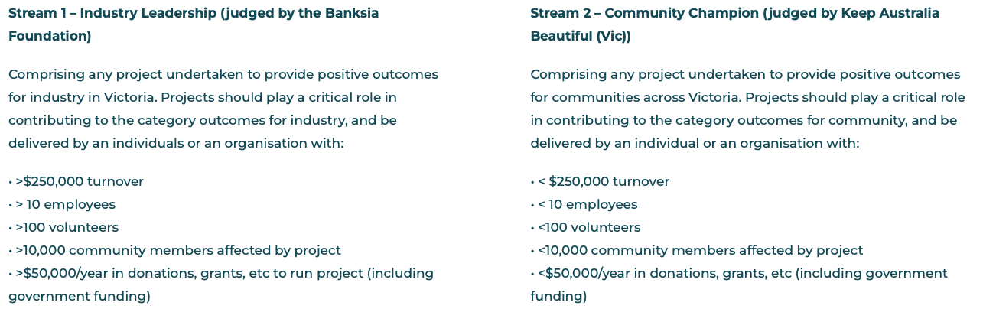

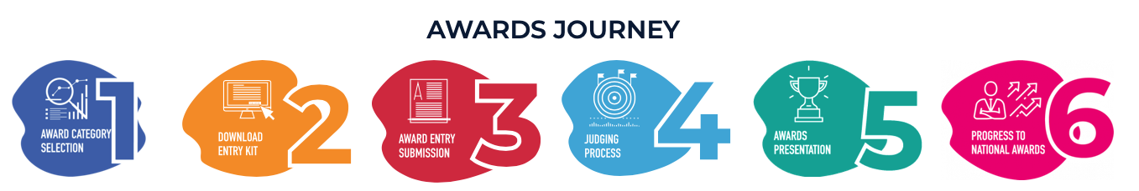

**Fees and Submissions**

Organisations can enter multiple award categories; however a fee applies for each award.

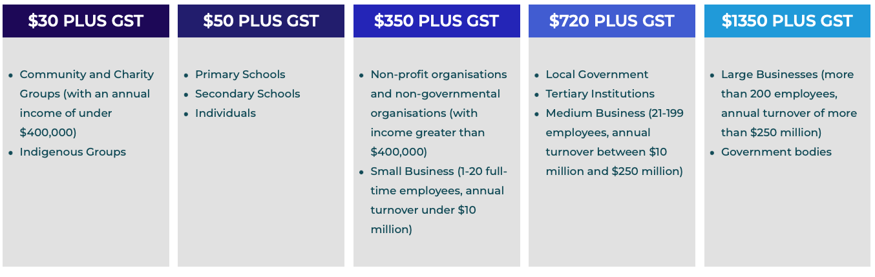

**Entry Fee Use**

* Administration cost to process entries
* Judging process
* COordinating award evening and annual events

**Judging Process**

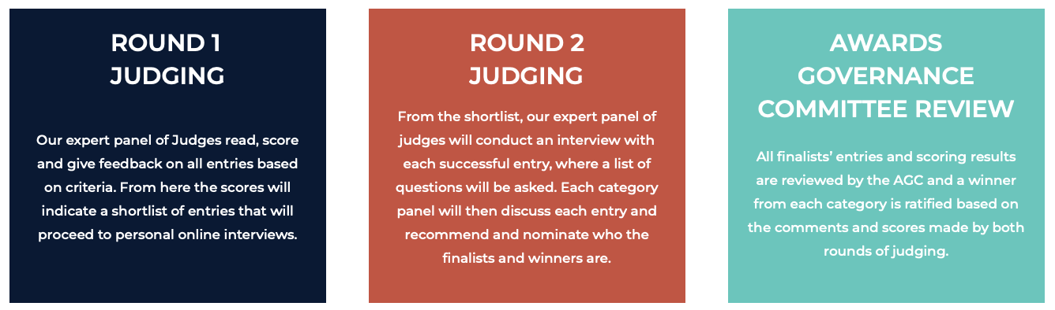

**Round 1** - Judges score and give feedback on ALL entries (Criteria based) ⇒ Scores are used to create a shortlist of entries.

**Round 2** - Judges interview shortlisted entries (Online) ⇒ Panel nominate finalist and winners

**Review** - Awards Governance committee (AGC) audit and ratify the selected winner.

Safeguards against conflicts of interest and ensure independency

*Jo Cain* = Chair of the Awards Governance Committee.

**Notes:**

Judges are volunteering experts in a specialist field.

Judges must absent themselves if there are any suspected conflicts of interest.

Judges are organised and overseen by Banksia foundation but are ultimately independent of the Banksia board and staff.

Premier's Sustainability awards judges are independent of Government and Sustainability Victoria.

**Premier's Sustainability Awards 2022**

Stream 1 (Industry Leader) assessed by Banksia

Stream 2 (Community Champion) assessed by Keep AUstralia Beautiful Victoria (KABV)

Email

[graz@banksiafdn.com](mailto:graz@banksiafdn.com)

stable categories from each year

feedback report

entry kit

planet protector actual entry

time for zoom

which category or sector

**W1 Banksia discussion**

Depth: not deep. Entry against criteria. Entry feedback is about how their entry is assessed against their entry criteria. Progress, results.

Banksia is not teaching them, only to provide advice. Judges are experts but don’t work in the field

No internal audits to prove results are real, lack of collaboration

Great writers on entry but poor interview and vice versa. Judges read entry to pose questions in interview

Different analysis across different awards

Dilemma, not just dealing with industry, ngo and gov but the whole community

Need feedback that does not require hours of analysis of the org before being able to give feedback

SME market needs priority

Bringing them to the industry help required

Feedback needs to be engaging and psychological barriers against feedback need to be broken down

The projects are the babies of the orgs and communities so they may not take feedback well

Different people are interested in different SDGs

Report card:

No one wants another layer of reporting

Progressive analysis to measure progressive

Have data so people can measure progress year on year

Translating the indicators into the report card

Different industries have different levels of difficulty in achieving different indicators

Is it developing a plan of progression year on year?

Identifying what is key to Australia

How can we translate all those findings into an IT program to display as a report card

Nothing is an ultimate, sustainability is a journey, no max point, improving on one’s best results

Mapping type thing?

DepFA makes a report to UN, could use as inspiration

How to assess

How to record

Definition of sector

Look at what sdg is achieved in the sector

What criteria as per entry kit

Can measure against industry/sector averages

How to quantify progress

Discuss with past winners and judges to find more information

Prioritise sdg17

How much impact relatively to size/starting point and how much effort spent to achieve and difficulties overcome